Practical 4
Controlling LED using Telegram App

Steps: -
- Click on Raspberry Icon > Programming > Thonny Python IDE
- On the Right Side Click on the Switch to regular mode > Close and reopen Thonny
- From the upper tab click on Tools > Manage Packages > Search telepot and Install
OR Use Below Steps
In the raspberry pi PC open Terminal and type
pip3 install telepot
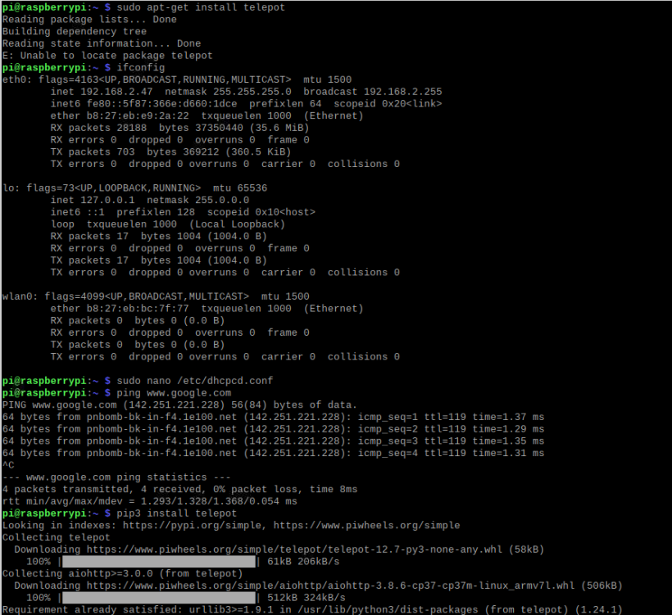
If not getting install or connection error go to File explorer > /etc > dhcpcd.conf file
Edit the IP address earlier it was – 192.168.0.1 Change to 192.168.2.1
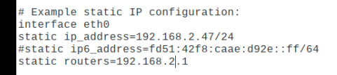

| LED Terminal | Pin Number | GPIO Number |
|---------------------|------------------|-------------|
| Red Positive | Pin 15 (LED 1) | GPIO 22 |
| Blue Positive | Pin 16 (LED 2) | GPIO 23 |
| Ground for LED 1 | Pin 9 | GND |
| Ground for LED 2 | Pin 6 | GND |
- Install Telegram app in phone.
- Search BotFather and Add
- Click on Open > create a bot > name the bot and username
- Copy the bot link for the further coding.
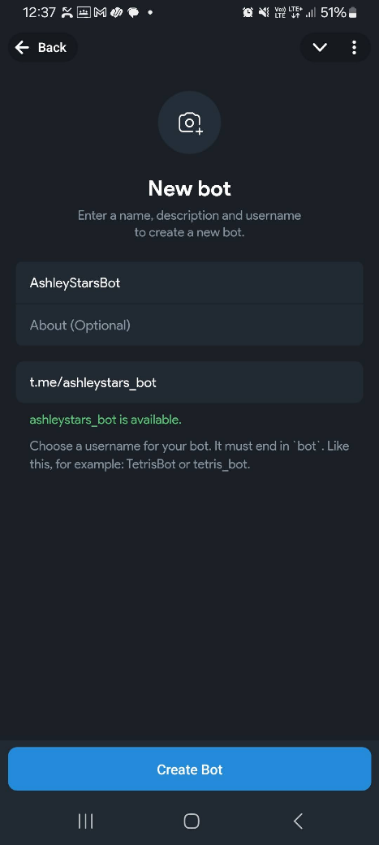
Code: -
import telepot
from telepot.loop import MessageLoop
from datetime import datetime
import RPi.GPIO as GPIO
from time import sleep

red = 22
yellow = 23

now = datetime.now()
GPIO.setmode(GPIO.BCM)
GPIO.setwarnings(False)

GPIO.setup(red, GPIO.OUT)
GPIO.output(red, 0)

GPIO.setup(yellow, GPIO.OUT)
GPIO.output(yellow, 0)

def action(msg):
chat_id = msg["chat"]["id"]
command = msg["text"]
print("Recieved: " + command)

if "on" in command.casefold():
message = "on "
if "red" in command.casefold():
message = message + "red"
GPIO.output(red, 1)
elif "yellow" in command.casefold():
message = message + " yellow"
GPIO.output(yellow, 1)

message = message + " light(s)"
telegram_bot.sendMessage(chat_id, message)

if "off" in command.casefold():
message = "off "
if "red" in command.casefold():
message = message + " red"
GPIO.output(red, 0)
elif "yellow" in command.casefold():
message = message + " yellow"
GPIO.output(yellow, 0)

message = message + " light(s)"
telegram_bot.sendMessage(chat_id, message)

telegram_bot = telepot.Bot("8293210490:AAGfJLjRkgsJTE3DbbAuY_pHtWl1sOMSrLA")
print(telegram_bot.getMe())
MessageLoop(telegram_bot, action).run_as_thread()

try:
while True:
sleep(10)

finally:
GPIO.output(red, 0)
GPIO.output(yellow, 0)
GPIO.cleanup()

- In Telegram Search BotFather > Open the chats
- Message /mybots
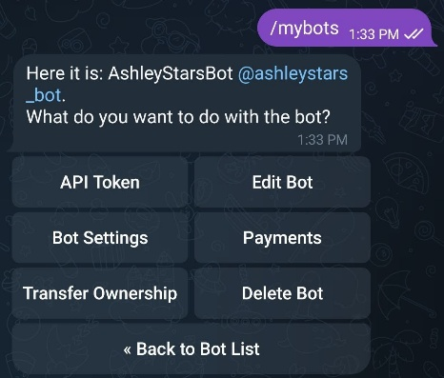
- Then choose the mybots and click on the @username
- Also Run the python code
- Message - /start
On red

Output: -
